Exp.No:30
30. Morphological operations based on OpenCV using Dilation technique.

Aim:
To perform the Dilation morphological operation on an image using OpenCV.
Procedure:
- Read the input image (Key chain.jpg).
- Create a structuring element (kernel).
- Apply the dilation operation using cv2.dilate().
- Resize the images for medium-size display.
- Display the original and dilated images.
- Save the output image.
Program:
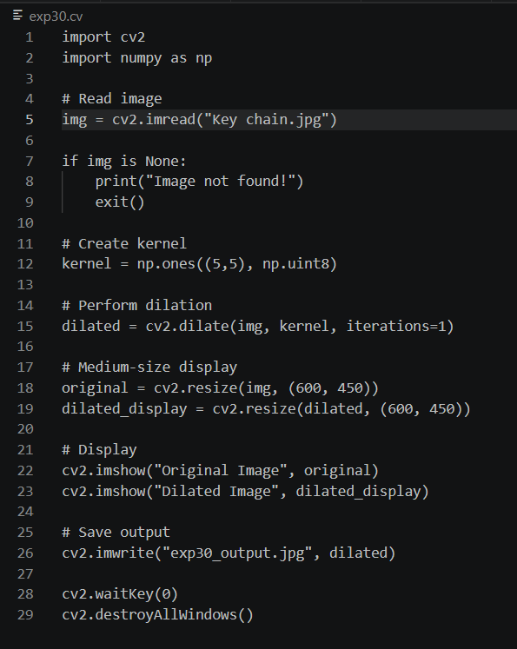
Input:

Output:
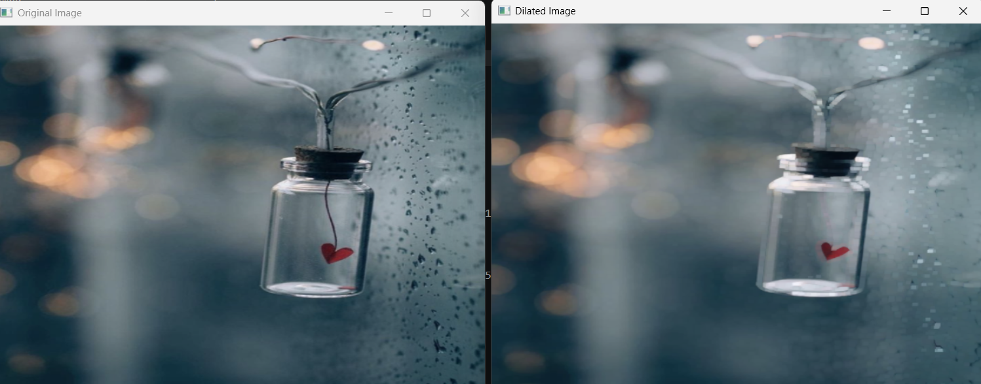

Result:
The dilation morphological operation was successfully performed on the input image. The dilated image was displayed and saved successfully.

